Syllabus: Android Training

Core Android

Chapter 1: Introduction to Android

o What is Android?
Android is a open source and linux based OS for mobile devices(smart phones, tablets)
It is developed by Google and later the OHA(Open Handset Alliance)

o Android API levels (versions & version names)
Version Name API Level
1.5 Cupcake 3
1.6 Donut 4
2.1 Eclair 7
2.2 Froyo 8
2.3 GingerBread 9 10
3.1 3.3 Honeycomb 12 13
4.0 Icecream Sandwich 15
4.1 4.2 4.3 JellyBean 16,17,18
4.4 KitKat 19
5.0 Lollipop 21
o Android Features
It is open source.
we can access lot of mobile applications developed in android.
It provides support for messaging services, web browser, storage(SQLite), connectivity(Bluetooth,Wifi...),media(audio,video)..

Chapter 2: Android Architecture

o Software Stack

o Linux Kernel
Kernel is the fundamental part of the OS.
Device drivers are present in this kernel
Memory management and process management done in Linux kernel

o Native Libraries
These libraries are running on top of the kernel.
C/C++ libraries.
Media library for audio and video files.
SQLite for database support.
Graphics library for 2G and 3G graphics.

o Android Runtime
It contains core libraries and DVM.
Core libraries contain Java Standard Edition and Android specific libraries.

o Dalvik Virtual Machine
It contains dex (Dalvik Executable)files
Efficient than class files.
Limited memory.

It is like JVM in Java.
Source files(java files) are converted into .class files using Javac
These .class files are converted into .dev files using dex compiler
These .dex files are converted into .apk files using aapt(Android Assets Packaging Tool)

o Application Framework
Provides classes used to create Android applications.
Activity Manager: manages application life cycle of an activity.
Resource manager: providing access to resources such as layout files,strings,graphics..
Content Providers: enable applications to access data from other applications(contacts)

Android App Structure
AndroidSampleApp
.settings
Assets(can copy html/css,audio,video,db files)
Bin(contains .apk file)
Gen[generated java files]
Libs(library)
Res
Drawable-hdpi(ldpi, mdpi, xhdpi, xxhdpi)
Layout(activity_main.xml)
Menu(main.xml)
Values(dimens.xml, strings.xml, styles.xml)
Src---com.example.aaa---MainActivity.java
AndroidManifest.xml

o Core Building Blocks
Core Building Blocks or fundamental components of a Android are
Activity
View
Intent
Service
Content Provider
Fragment
Android Manifest.xml

Activity is a class that represents single screen.
View is UI element which is visible on the screen.(Button, Textview..)
Intent is used to invoke components.
Start the service
Launch the activity
Display a webpage
Service are process that run in background for a long time.
Content Provider are used to share data between the applications.(sending message which including contact from contacts.)
Fragment is like a part of a Activity. An Activity can display one or more fragments on the screen at a time. It can be added or removed while activity is running.
Android Manifest.xml contains information about activities, services and permissions.
It will give permissions to do any actions.
Broadcast Receiver The Android system uses broadcasts messages (often are called Intents or Events) to transfer information to applications. The Broadcasts can be sent either by Android apps or, most commonly, by the system itself. (low battery,BATTERY_FULLY CHARGED, LOW_MEMORY)

Chapter 3: Application Structure (in detail)

o AndroidManifest.xml

o uses-permission & uses-sdk
o Resources & R.java
o Assets
o Layouts & Drawable Resources
o Values
o Android Emulator
If you don't have a real device it is best to run, debug and test the android applications.Android Emulator is used to run, debug and test the android applications.
o Multi support Screens
Screen sizes
Small size 2-3.7
Nomal size 3.7-4.3
Large size 4.0-7.1
Extra large size 7-10.0
Screen Density
Low density---100dpi to 130dpi
Medium density---120dpi to 180dpi
High density---180dpi to 280dpi
Extra high density---280dpi to 360dpi

Unit of dimension
At runtime dp is converted in to pixels.
Number of pixels in a physical area..simply dots per inch(dpi).
Density Independent Pixels
Px=dp*(dpi/160)

Ldpi-(0.75x) 1dp=0.75dp in ldpi
mdpi(baseline) 1.0
hdpi(1.5x) 1.5
xhdpi(2.0x) 2.0
App Icon Dimensions
Ldpi=36*36 pixels
Mdpi=48
Hdpi=72
xhdpi=96
Xxhdpi=144
3:::468
Background Dimensions
240x320px
320x480
480x800
720x1280
3 4 6 8
Storing image in specific folders
Drawable---default

Multiple Layout devices
Generic(version 2.2 onwards api level8onwards)
Res/layout/my_layout.xml
Res/layout-small/my_layout.xml
Res/layout-normal/my_layout.xml
Res/layout-large/my_layout.xml
Res/layout-xlarge/my_layout.xml

Res/layout-land/my_layout.xml
Res/layout-small-land/my_layout.xml
Res/layout-normal-land/my_layout.xml
Res/layout-large-land/my_layout.xml
Res/layout-xlarge-land/my_layout.xml

Google(version 3.2 onwards api level 13 onwards) (5)
Potrait and landscape
Res/layout/my_layout.xml
Res/layout-sw320dp/my_layout.xml
Res/layout-sw480dp/my_layout.xml
Res/layout-sw600dp/my_layout.xml
Res/layout-sw720dp/my_layout.xml

o Activities and Activity lifecycle
Activity is a class that represents a single screen.
Android program takes initiation with the activity(on create()) (like main (psvm() method)containing class in java,void main() in c)
Application contains any number of activities.Among those select one activity as initiative.
Reuse the same activity across several activities.
an activity class loads all UI components using the XML file available in res/layout folder of the project.
setContentView(R.layout.activity_main);
loading UI components from res/layout/activity_main.xml.
There are 7 life-cycle methods of activity. They are
onCreate() --called when activity first created
onStart() ---called when the activity is becoming visible to the user.
OnResume()--called when the activity will start interacting with the user.
onPause()---called when the activity is not visible to user
onStop()---called when the activity is no longer visible to the user.
onRestart()---called after the activity is stopped, prior to start.
onDestroy()---called before the activity is destroyed.
onCreate()-->onStart()-->onResume()-->Activity is running
onStop()--->onRestart()-->onStart()-->onResume()-->Activity is running

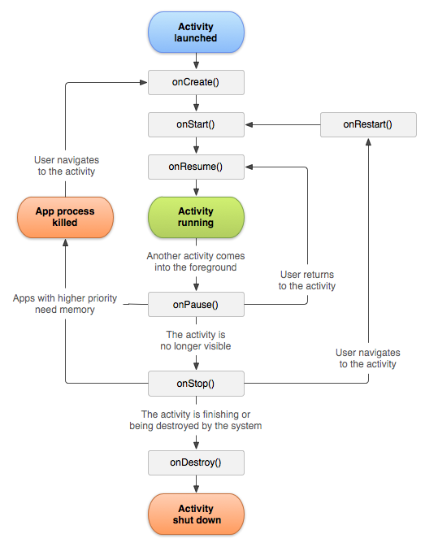
o First sample Application
//MainActivity.java
Public class MainActivity extends ActionBarActivity
{
Protected void onCreate(Bundle savedinstancestate)
{
super.onCreate(savedinstancestate);
setContentView(R.layout.activity_main);

}
}
Chapter 4: Emulator-Android Virtual Device

o Launching emulator
o Editing emulator settings
o Emulator shortcuts
o Logcat usage
o Introduction to DDMS
o Android Emulator

Chapter 5: Basic User Interface Design

o Widgets ( TextView, Button, CheckBox......Etc.)
TextView(Normal,small,large)
EditText
Button(Small)
ToggleButton(ON/OFF)
Switch(ON-OFF)
Checkbox
RadioButton
CheckedTextview
Spinner
ProgressBar(large,Normal,Small,Horizontal bar)
SeekBar
QuickContactBadge
RadioGroup
RatingBar

o Layouts ( FrameLayout, LinearLayout, TableLayout, RelativeLayout, GridLayout)
Linear Layout
Relative Layout
Table Layout
Frame Layout
Grid Layout
o Views (ListView, GridView, WebView, TabHost , ExpandedListView )
List View
Grid View
Web View
Tab Host
Tab widget
Expanded Listview
ScrollView
Horizontal Scrollview
Search View

o Handling User interaction Events
EventListeners
onClickListener
onLongClickListener
onFocusChangeListener
onKeyListener
onTouchListener
onCreateContextMenuClickListener

Chapter 5: Advanced User Interface Design

o List Controls

o Custom List Controls
o Picker Controls
TimePickers
DatePickers

o Selection Components

o Adapters
BaseAdapter(It is the base for all the adapters below)
It is a abstract class.
It contains three abstract methods
getItem()
getItemCount()
getItemId()
getView()

ArrayAdapter
CursorAdapter
SimpleCursorAdapter
o Custom Styles & Thems

Chapter 6: Menues & Dialogues

o Creating Menus

o Submenus
o Alert Dialog

o Progress Dialog

Chapter 7: Intents

o Explicit Intents
o Implicit intents

Chapter 8: Preferences

o SharedPreferences
o Internal Storage
o External Storage
o Database Storage

Chapter 9: SQLite Databse

o Introducing Sqlite
o SqliteOpenHelper
o Opening and Closing a Databse
o Creating Tables
o CURD Operations
o Working With Cursors
o Working with Sqlite Database Browser

Chapter 10: WebServices

o What is web service ?
o JSON
o XML (Dom, SaxParser, XmlPullParser)

Advanced Android

Chapter 11: Sensors and Hardware API

o Custom Activity

o Fragments.
o Camera Framework

Chapter 12: Other Components

o What is Services ?
o Service LifeCycle.
o Broadcast Receiver
o Content Provider
o Multimedia
o Location API
o Android Google Map
o Speech API
o Android Graphics
o Animations

Chapter 13: Notifactions & Alarms

o Creating Notifactions
o Working With Alarms.

